Bar Chart
https://app.powerbi.com/view?r=eyJrIjoiYWYxYWJlYTEtZWRkMS00Y2Y1LWFhZTQtMDgzNDY3NDI0YTc0IiwidCI6IjExMTNiZTM0LWFlZDEtNGQwMC1hYjRiLWNkZDAyNTEwYmU5MSIsImMiOjN9
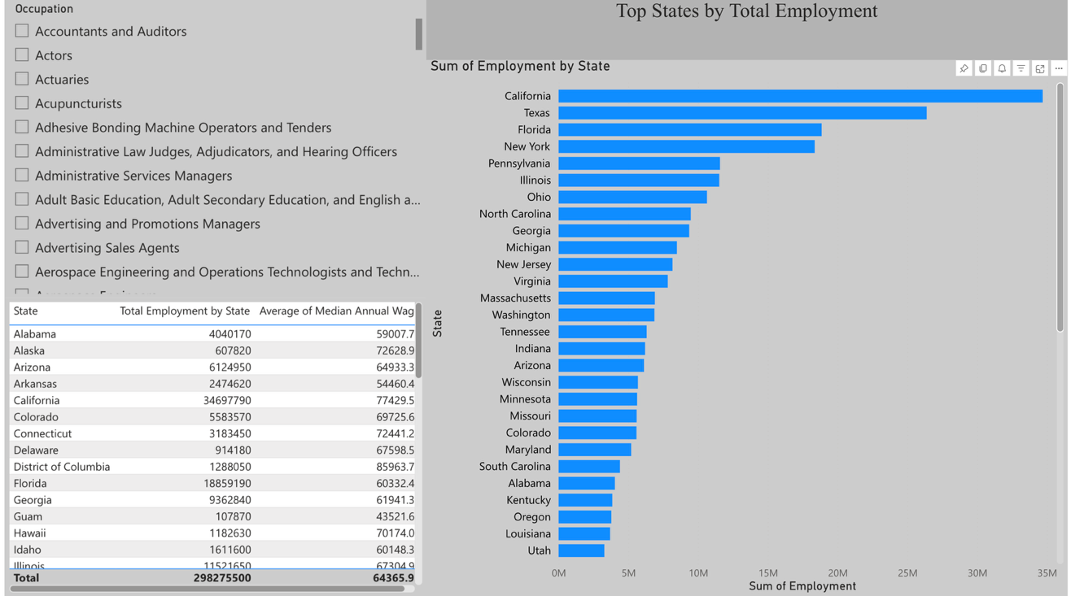

Scatter Plot
https://app.powerbi.com/view?r=eyJrIjoiMjQyYmVjMjktZjFiMi00NTgzLTgyZWEtYjJiYmEzNWFkZmVkIiwidCI6IjExMTNiZTM0LWFlZDEtNGQwMC1hYjRiLWNkZDAyNTEwYmU5MSIsImMiOjN9
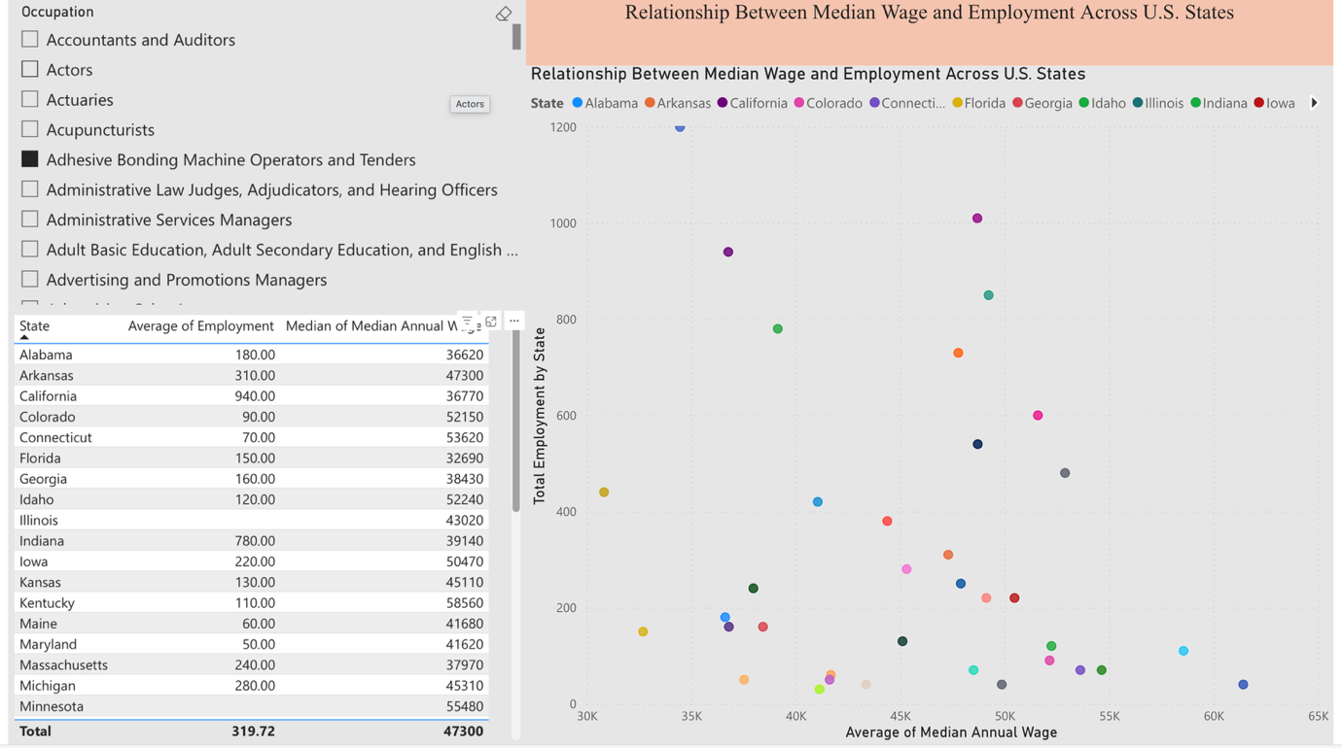
Geospatial Map
https://app.powerbi.com/view?r=eyJrIjoiODA0YmJkMzMtNjNkOC00Zjc3LWEyM2YtYzExMDNhMDgzODljIiwidCI6IjExMTNiZTM0LWFlZDEtNGQwMC1hYjRiLWNkZDAyNTEwYmU5MSIsImMiOjN9
